MINUTES OF ANNUAL GENERAL MEETING OF THE
NUMERALLA / COUNTEGANY
BUSH FIRE BRIGADE

Friday 20th May 2011
NUMERALLA DIGGERS HALL
MEETING COMMENCED AT 19.05

In attendance:
Steve Donkers  Peter Wood  Craig Mitchell  Peter Vlahos  Anne Robinson  Ian Jauncey  Ailish Pope  Chris Gaskin | Terry Myers  Janice Goodwin  Jim Darrant  Jenni Roberts  Geoff Ferguson  Les Robinson  Chris Allen  Jim Wharton | Bruce English  Barbara Myers  Mark Shubert  Sandra Donkers  Barbara Shubert  Regina Roach  Barry Aitcheson  Lyle Westaway

1 APOLOGIES
Dustin Myers  Coral Talbot  Paul Sullivan | Peter Jackson  Graham Litchfield | Max Talbot  Langdon Gould

2 MINUTES OF ANNUAL GENERAL MEETING Friday 11 June 2010

Motion:
Minutes of Annual General Meeting held on Friday 11 June 2010 considered as true and correct.

Moved – Steve Donkers Seconded – Barb Myers Minutes accepted.

3 BUSINESS ARISING FROM PREVIOUS MINUTES

- Shed upgrades deferred to general business
- There has been no progress with the upgrade of the shed siren regarding its ability to oscillate and be activated by the pager system.
  - Terry Myers will progress this with Monaro team (Chris Allen)
- Peter Vlahos reports that the cost of manufacturing the mussels ourselves is prohibitive.
  - Barry Aitchison and Craig Mitchell will investigate the availability of small plough discs to assist with building our own.
- The proposed purchase and installation of a winch on the Cat 9 has been deferred indefinitely due to concerns about weight.

4 CORRESPONDENCE

List of key correspondence attached. Steve Donkers highlighted that there are numerous emails that are stored on personal email systems and that it is now intended to utilise the Gmail account for all Brigade email correspondence (ncbfbrfs@gmail.com).

Summary Of Key Correspondence
Period 01 April 2010 to 31 March 2011
Correspondence In
Date | From | Description
12-Apr-10 | Fire Control | Captain's Meeting 09/03/2010 Minutes
27-May-10 | Fire Control | Defribilitator Information
23-Jun-10 | Monaro Team | Appointment of Brigade Officers
09-Sep-10 | Monaro Team | Notice of Captains Meeting 28/09/2010 + Captain's Meeting 09/03/2010 Minutes
10-Sep-10 | Monaro Team | Land Status for Funding
23-Sep-10 | BMR Solicitors | Land Trusteeship
29-Sep-10 | CMSC | Apology for SGM Attendance and comment re trust
14-Oct-10 | Monaro Team | Captain's Meeting 28/09/2010 Minutes
09-Dec-10 | Monaro Team | Shed Proposal from Chris Allen
01-Mar-11 | Monaro Team | Upcoming Events
07-Mar-11 | Monaro Team | Captain's Meeting 30/03/2011 Notice and Agenda
Correspondence Out
Date | To | Description
10-May-10 | Membership | AGM Notice
17-Sep-10 | Membership | Newsletter, SGM Notice
07-Oct-10 | CMSC | Request for Advice Re Transfer of Control of Shed Site to CMSC
15-Dec-10 | Monaro Team | Response to Shed Proposal
14-Jan-11 | Monaro Team | Brigade Response to Shed Proposal at Hall by Monaro Team

Moved – Steve Donkers Seconded – Mark Shubert
Report accepted.
5 TREASURER’S REPORT

Report Attached
Total Brigade funds available at 03 April 2011 is $38,556.03
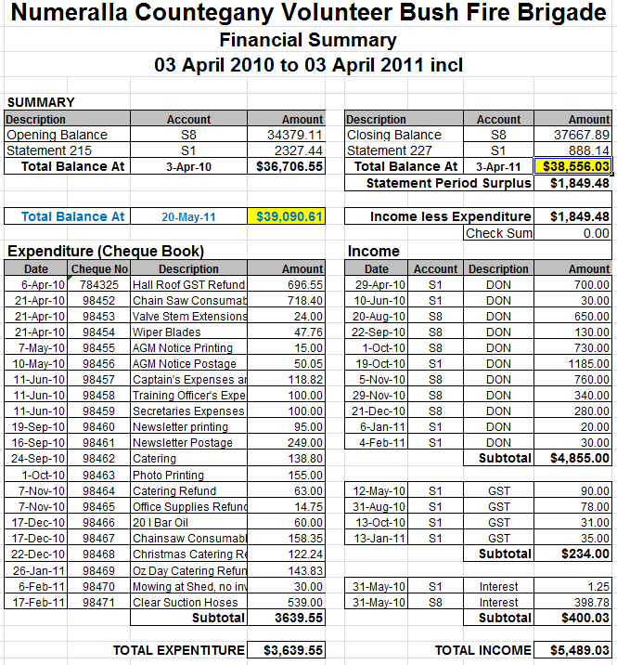

Moved – Steve Donkers Seconded – Mark Shubert
Report accepted.

Motion to obtain audit as per constitution, section 9.5.
Moved – Steve Donkers Seconded – Bruce English
Treasurer to obtain audit when time permits, will not be before September 2011 die to absence.

6 CAPTAINS REPORT

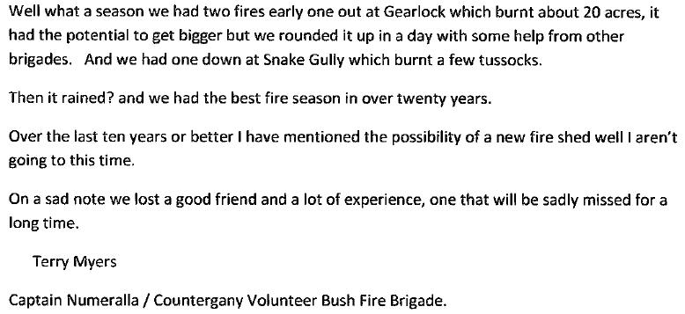

Moved - Terry Myers Seconded –Jenni Roberts
Report accepted.

7 TRAINING OFFICERS REPORT

Report Attached

Moved – Bruce English Seconded – Barbara Myers
Report accepted.

8 EQUIPMENT OFFICER’S REPORT

- One length of transparent suction hose purchased for each truck
- Miscellaneous chain saw consumables purchased and distributed
- Modifications undertaken to Cat 1 lockers to improve access and functionality
- Routine stocktakes and maintenance done as required to maintain operational capability

Verbal Report
Moved – Mark Shubert Seconded - Bruce English

- ELECTION OF OFFICE BEARERS

Craig Mitchell advised that he had heard that the Monaro Team had expressed concerns about the lack of leadership within the Numeralla Brigade. Craig asked for confirmation from the Superintendent Monaro Team and indicated that if this was the case then the Executive would not stand for re-election.
No comment was forthcoming from the Monaro Team.

PRESIDENT
Craig Mitchell
Nominated – Mark Shubert Seconded – Bruce English
Craig Mitchell elected President

SECRETARY/TREASURER
Steve Donkers
In accepting the nomination Steve highlighted that if an apparent communication breakdown with Monaro Team could be attributed to himself he would not accept the nomination. The Brigade indicated an overwhelming show of support for Steve, and as such, the nomination was accepted.

Nominated – Mark Shubert Seconded – Bruce English
Steve Donkers elected Secretary/Treasurer.

CAPTAIN
Terry Myers
Nominated – Bruce English Seconded – Mark Shubert
Terry Myers elected Captain

SENIOR DEPUTY
Steve Donkers
Nominated – Craig Mitchell Seconded - Bruce English
Steve Donkers elected Senior Deputy

DEPUTIES
Peter Vlahos
Peter Jackson
Les Robinson
Craig Mitchell
Bruce English
Nominated – Mark Shubert Seconded – Mark Shubert
The above nominated deputies were duly elected
CALL OUT OFFICERS
Janice Goodwin was thanked for her contribution as a call out officer over the years.

Members were reminded that there is no limit on the number of acll out officers but nominated persons should endeavour to be available throughout the fire season.

Election of Call Out Officers
Barbara Myers, Belinda Vlahos, Suzie Mitchell
Nominated – Craig Mitchell Seconded - Peter Vlahos
Call Out Officers elected as above

PERMIT ISSUING OFFICERS
Terry Myers, Steve Donkers, Geoff Ferguson
Nominated – Barbara Myers Seconded - Mark Shubert
Permit Issuing Officers elected as above

TRAINING OFFICER
Bruce English
Nominated – Sandra Donkers Seconded – Mark Shubert
Bruce English elected Training Officer

ASSISTANT TRAINING OFFICER
Regina Roach
Nominated – Sandra Donkers Seconded – Ian Jauncey
Bruce English elected Training Officer

EQUIPMENT OFFICERS
Peter Vlahos, Dustin Vlahos, Bob Smith, Mark Shubert
Nominated – Bruce English Seconded – Barbara Myers
Equipment Officers elected as above

BRIGADE RFSA DELEGATES
Bruce English, Max Talbot
Nominated – Barbara Myers Seconded – Jenni Roberts
RFSA Delegates elected as above
While the RFSA was formed to act in the interests of all volunteer and fulltime members of the RFS. Over the last few years some volunteer members of the RFS have become dissatisfied with the role of the RFSA and have formed the Volunteer Fire Fighters Association. Numeralla-Countegany members’ attention was drawn to this organisation as an alternative to the RFSA. It was also agreed to consider Brigade membership of the VFFA at the 2011-2012 AGM.

10 MONARO TEAM REPORT

Presented by Chris Allen and Barry Aitchison
Report Attached
Moved – Barbara Myers Seconded – Jenni Roberts
Report accepted.

11 RFSA REPORT

Bruce English reported that:
The RFSA is a Statewide non-partisan member association that represents the interests of 70,000 members of the world's largest volunteer firefighting service (http://www.rfsa.org.au/rfsa/index.php?D=1).

The Brigade appreciates that the RFSA continues to host the Brigade’s website free of charge http://www.numerallacountegany.rfsa.org.au/

Information from RFSA has been less than forthcoming. What information has been obtained is either through the RFSA magazine, website or through other links such as MyRfs.

Reports on matters affecting Brigade members have not been drawn to attention by the local representatives. For example throughout the year various Draft Reports have been released by the RFS for comment. These include the Draft Flexible Membership Model, and more recently, a Rank Review Discussion Paper. Additionally, prior to the NSW election, the RFSA asked the major political parties how they saw the RFS developing in the longer term. While feedback information became
available it was rather late in the lead up to the election.

The last twelve months or so have also seen an increase in reviews of such things as operating procedures etc. It is noted, from web sites, that Brigade members’ interests are represented but it is somewhat ironic that most Brigade members remain unaware of these reviews etc.

Generally Brigade members are unaware of the above types of reports unless they are in the habit of checking relevant websites. It is unfortunate that in this day and age of electronic capability that ‘push technology’ is not utilised.

The Superintendent of the Monaro Team (Jim Darrant) adviseed that there was no obligation for a Brigade to nominate a Delegate to the RFSA. After discussion however, the Brigade decided that it will continue to nominate an RFSA Delegate; will attempt to gain greater information from the RFSA and will review the situation at the next AGM.

Moved – Bruce English Seconded – Barbara Myers
Report accepted.

12 REVIEW OF SCHEDULE OF RATES

A motion to revise the current schedule of rates by increasing the requested annual donation from landholders and residents by $5 was moved.

Moved – Steve Donkers Seconded – Mark Shubert
Motion accepted

Shannon’s Flat Brigade’s Channel 6 repeater is not currently operational
Barry Aitchison suggested that Brothers Brigade’s Channel 4 repeater may be worthy of support in the future as it can also be utilised in our Brigade area.

13 GENERAL BUSINESS

- Automated External Defibrillator (AED)
  - These have been provided by the RFS for all ‘Red’ trucks. Location on the trucks is to be identified by a sticker, however that location is problematic in some cases because of the excessive size of the storage cases provided, and further training will occur as and when required.

- Neighbourhood Safer Places (NSP)
  - The designation of the Hall as an NSP by the Local Emergency Management Committee places no additional responsibilities on the Brigade. The Hall meets the criteria created by the State Government in response the Victorian ‘Black Saturday’ Fires. Discussion ensued about its suitability and whether it would/could be used at all. Monaro Team informed the Brigade that if an alternate site that met the criteria was identified, a review could be undertaken. The consensus view seems to be to leave it as is, largely ignoring it, and consider its merits ‘on the day’.

- Hazard Reductions
  - Undertaking proposed hazard reductions have been problematic due to weather and additional constraints on HR11 as a result of the identification of significant Koala activity. The burns are still planned to occur when circumstances allow. If any additional hazard reductions are considered desirable then it should be discussed with the Captain in the first instance.

- Possible Boundary Changes(s)
  - With the likely formation of Kybean Brigade, a restructure of boundaries would be required. Operations Officer Monaro Team (Barry Aitchison) will convene a meeting of the Captain and Deputies in August to facilitate a review. The review will, amongst other things, conduct on site inspection of the prospective boundaries.

- Catering Trailer
  - Operations Support Officer, Chris Allen, will obtain details and costs associated with the now operational Bredbo catering trailer.

- Shed Development
  - Solar Panels
Solar panels have recently been installed on the existing shed by Clean Energy for Eternity. Concern was expressed that the Brigade had not been advised of the installation, let alone asked for its permission to install on a privately owned shed. Monaro Team indicated that communication with Clean Energy for Eternity had been problematic for some time. It was also stated by Monaro Team that once the new shed was constructed the panels would be relocated onto it.

  - Land Transfer
A meeting was held on 18/05/2011 between the Phillip Blyton and Janice
Goodwin, the tenants and ‘honorary trustees’ of the Brigade Shed land and the Brigade executive to discuss the transfer of control of the land to Council such that the RFF can be accessed for the shed development.
It was agreed that the current tenants would sell the land to CMSC for a
‘peppercorn’ amount. Operations Support Officer, Chris Allen will facilitate this process.

  - Shed Site Plan Proposal
Monaro Team presented the latest shed proposal, including a site plan. A copy is attached. Superintendent of the Monaro Team, Jim Darrant, advised that the proposal now includes removal of the existing shed. Mr Darrant advised that the demolition and removal was considered necessary as neither the RFS nor the Council supported retention of the old facility once the new shed was erected. The Brigade was unaware of the proposal to demolish the existing shed and the proposal created some concern amongst the members present. Winston Phillips undertook to liaise with CMSC regarding this issue.

Meeting Closed at 22.00

